**ENGL 4366 – Technical and Professional Editing**

Date: 11 December 2018

To: Dr. Lancaster

From: Taylor Watkins

Subject: Final Editing Project

As per your request, I have provided my final technical editing project for the semester below.

In its edited condition, the paper sits at 3275 words. This is a shortened amount from its original unedited version, which was around 3340 words. The project that I edited was an essay written by a group of undergraduate chemical engineering students—Nicholas Sosa, Evan Morrison, Reed Nevermann, and Juan Torres—for their Exposition of Technical Information class, a class that all engineering students are required to take in order to ensure that they are satisfactory in their technical communication skills as engineers.

Because the group had to pick team names for their projects, the individuals who wrote the essay decided to choose “Team Cope” as their group name, which is included along with their individual names on the cover page of the essay. Their prompt, as it seems, was that they could pick any subject that they wanted, as long as it discussed methods of the ways that their subject innovated in great detail.

The essay is entitled “Innovations of Marvel Studios” and covers a variety of the ways that Marvel Enterprises and their subsidiaries innovated their way to the elite film and comic book industry that it is today. It provides a brief history of Marvel Enterprises, the pivotal point in their success, and how that success has displayed their innovative decisions.

Final Technical Editing Project:

Editing “Innovations of Marvel Studios”

Taylor Watkins

Professor Amber Lancaster

11 December 2018

Texas Tech University

Table of Contents

**List of Figures ……………………………………………………………………………………………………………….. 4**

**Introduction …………………………………………………………………………………………………………………. 5**

**Communicating Externally .……..…………………………………………………………………………………... 6**

**Suggestion-Style Edits ………………………………………………………………………………………………….. 7**

**Using Word’s Track Changes ………………………………..…………………………………………………….... 8**

**References ……………………………………………………………………………………………………………………. 9**

**Appendix ……………………………………………………………………………………………………………………… 10**

List of Figures

**Figure 1 …………………………………………………………………………………………………………………. 6**

**Figure 2 ………………….……………………………………………………………………………………………... 7**

**Figure 3 ……………..………………………………………………………………………………………………….. 7**

**Figure 4 ……………………………………………………………………………………………………………..….. 8**

**Figure 5 …………………………………………………………………………………………………………..…….. 8**

# **Introduction**

*Getting the Project*

For my Final Editing Project in my ENGL 4366 class, which I took as a graduating senior at Texas Tech University, we were to go out into the world and find a client who needed a piece of technical writing to be edited. We had a lot of flexibility on this project—the only requirements were that the manuscript that was to be edited had to be a minimum of 3000 words and stand as a credible piece of technical writing. The purpose of this project was to give us real-world experience in the technical editing field rather than solely experiencing a classroom environment, and I believe that it helped us to reach out and communicate with people that would not typically need to be approached in an English class.

*Team Cope*

I contacted a person that I had connections within the chemical engineering department at Texas Tech, and he informed me that he and a group of his classmates were writing a technical document for their Exposition of Technical Information class—a class required for all engineering students to take in order to learn how to communicate in the engineering field. I requested to edit their essay upon its completion as part of my project, and after getting permission from his group and his professor of the class, I was allowed to edit the document.

The group had to pick a team name as a requirement, and they decided to go with the name “Team Cope”. Team Cope consisted of four chemical engineering students—Nicholas Sosa, Evan Morrison, Reed Nevermann, and Juan Torres. Team Cope’s prompt was to find a company that showed a great amount of innovation and how that company got to where it is today, and as they shared a common interest, Team Cope selected Marvel Enterprises as their innovative subject. Their essay focused on how Marvel Enterprises achieved their ultimate success in the modern day by hiring new management, creative thinking, and having a passion for the industry. The manuscript sat at 3340 words when it was submitted to me to edit.

*New Information*

There were many things I learned during this project, as it was the first time that I had ever had to reach out to an outside source to edit a manuscript before. However, what I feel that had the most significance to my field—and what will be covered in the remainder of this report—is learning about communicating externally, practicing suggestion-style edits, and getting experience in using Microsoft Word’s Track Changes.

# **Communicating Externally**

I believe that the most beneficial gain that I received from this project is learning how to reach out to outside sources and work with them in order to achieve the common goal. In previous classes, most if not all of my work was provided by the professor or found in the university library. With this project, however, I had to efficiently and responsibly discover contacts that I could use in order to obtain a technical document that fit the requirements of the project.

I believe that my situation was a bit more unique, as I had to work with four authors rather than just one. Some complications could have certainly risen from this, as one of the authors could have disagreed with some of my edits and caused confusion for the other three as well as myself on where to go from there. Luckily, however, the group insisted that Nicholas would act as a “spokesperson” for the group as far as edits went, so I mainly communicated with him for most of the project, although there were two or three times when I did meet with the group as a whole in person.

Most of our communication was via email and in person. As we did not have too many chances to allow the entire group to meet, I met Nicholas in person more frequently than the other three offers. All documents were sent via email as well, through both Word documents and PDFs. My edits were sent solely through Word documents, however, because of the use of the Track Changes tool, which will be discussed later in the report.

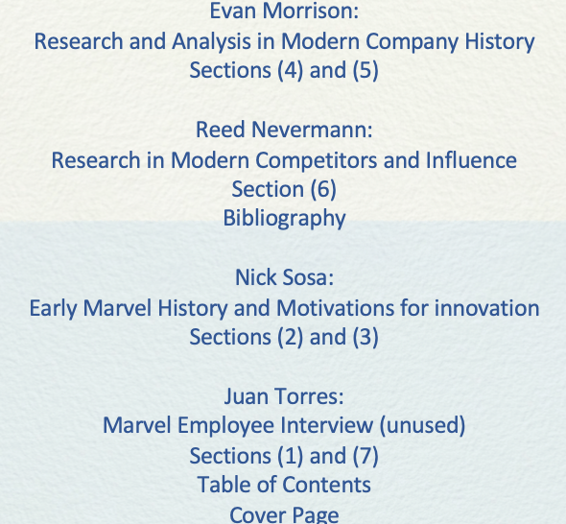

To the right in Figure 1 is an image from the essay’s cover page that lists the authors of Team Cope and the sections that they individually worked on.

It is clear that each of the authors would have been more sensitive to the edits within their own individual sections, so it is fortunate that I had little trouble in distributing them.

I believe that I gained an important skill concerning communicating externally, and I will be less intimidated by the concept should I have to do so in my future editing career.

*Figure 1*

# **Suggestion-Style Edits**

In my personal opinion, the most efficient way to convince an author to put an edit into place is by using suggestion-style edits. These edits make the author feel that they are still in control of their manuscript and poses more of a choice for the author rather than a command. Suggestion-style edits are less abrasive than a direct style of edit, and due to my knowledge of this, I used suggestion-style edits throughout my editing process for Team Cope’s essay.

The language played a big factor in my suggestion-style edits. “Perhaps” and “maybe” and “should” were words that were used many times in my comments to indicate that, while I was not trying to force the authors into any type of decision, it would be in their best interest to follow my instructions and revise the essay in the way that I was suggesting. Question marks, additionally, followed most of my suggestion-style edits, as they implied that the edit was up to interpretation of the author, and that they still had the freedom to decide what was best for their manuscript.

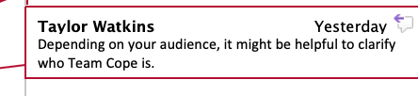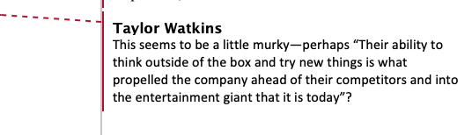To the left in Figure 2 and Figure 3 are two examples of the way that I used suggestion-style edits towards Team Cope’s essay. In Figure 1, you can see how “perhaps” was used, as well as the question mark at the end. In Figure 2, the “might” also implies suggestion rather than command, even though the edit is not followed up with a question mark.

*Figure 2*

I believe that suggestion-style edits were very useful in this project because they not only helped me get my point across to the authors without being abrasive, but they also taught me the skill to work with different audiences and decide which type of edit is best for which kind of author.

*Figure 3*

# **Using Word’s Track Changes**

The duration of this project was the first time I experienced using Word’s Track Changes tool. Before the project was assigned, I had been using Word for quite some time without realizing that the tool was there to be used for any sort of project that required editing in the past, and now that I have utilized Track Changes, I can certainly assume that it is a tool I will be using many times in the future.

At first, using Track Changes took some getting used to. There were many notifications that came with doing the simplest things, such as deleting a letter or making a new paragraph or changing the margins of a page, and it did not take long for Team Cope’s manuscript to be filled with the red notifications of Track Changes. However, after I became used to how Track Changes operated, I realized what a useful editing tool it was, and when paired with the comments that I inserted on the manuscript as well, I believe that it benefitted Team Cope’s manuscript immensely.

Many of the edits that I made on the manuscript with Track Changes were capitalization errors, spelling errors, and making new paragraphs. However, one of the most significant things that I had to do while using Track Changes was to make a large amount of changes to the manuscript’s subheaders. The spacings for them in reference to the rest of document were poorly formatted, and each subheader was not only bolded and underlined, but it also had a colon following it—having the three altogether was simply unnecessary. I removed the colons and fixed the spacing issues, and in doing so, I believe that I made Team Cope’s manuscript document design more professional in appearance.



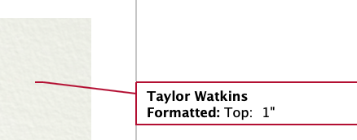To the left in Figure 4 and Figure 5 are two examples of ways that I used Word’s Track Changes tool. Figure 4 displays the notification that occurred whenever I deleted the colon on one of the manuscript’s subheaders. Figure 5 occurred when I formatted the margins of the document to match the APA style standards of formatting.

*Figure 4*

Because Track Changes is one of the most popular tools for an editor to use, I believe that I will use it frequently in my future editing projects and in my career as an editor.

*Figure 5*

References

1. Purdue Online Writing Lab. ﻿General Writing FAQs.﻿ Retrieved from [**https://owl.purdue.edu/owl/general_writing/general_writing_faqs.html**](https://owl.purdue.edu/owl/general_writing/general_writing_faqs.html)
2. Sosa, N., Morrison, E., Torres, J., & Nevermann, R. (2018). *Innovations of Marvel Studios*. 4December

Appendix



**Final Technical Editing Project**

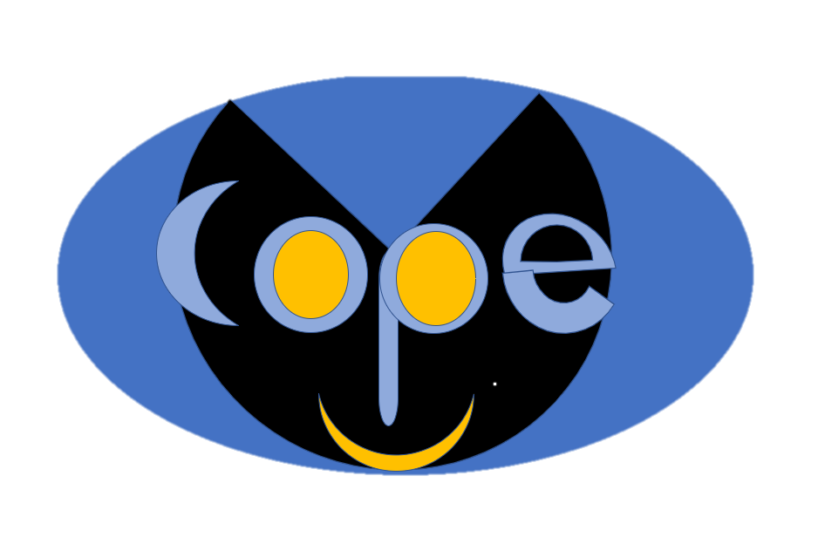Team Cope

Evan Morrison:

Research and Analysis in Modern Company History

Sections (4) and (5)

Reed Nevermann:

Research in Modern Competitors and Influence

Section (6)

Bibliography

Nick Sosa:

Early Marvel History and Motivations for innovation

Sections (2) and (3)

Juan Torres:

Marvel Employee Interview (unused)

Sections (1) and (7)

Table of Contents

Cover Page

CHE 2306 – Exposition of Technical Information

Section 001

October 2018

Table of Contents

1. Introduction2
2. The Downfall of Marvel Comics2
3. Formation of Marvel Studios3
4. New Direction and Leadership Changes4
5. Beginnings of Success 7
6. Innovation and Rise to the Top7
7. Conclusion9

**Introduction**

When it comes to bringing superheroes to film, few other credible companies have been able to match the overwhelming success of Marvel Studios. Today, Marvel Studios’ films have grossed billions of dollars in ticket sales across the globe, and the company has received adoration from filmgoers and comic book lovers alike.

Before they were the goliath in the entertainment industry that they are today, Marvel Studios’ former parent company, Marvel Enterprises, faced financial trouble throughout the early 1990s and 2000s, forcing them to take the company in an entirely new direction. Their financial instability, reorganization of the company, and President of Production Kevin Feige’s, passionate leadership has allowed Marvel to drive innovation in the film industry, a medium in which they had little experience. The company’s rejuvenation caused them to develop new methods of both character development and actor selection and build relationships between characters and viewers. These factors ultimately lead to their primary innovation: the creation of their cohesive Marvel Cinematic Universe, which is regarded as the world’s largest entertainment series and enjoyed by hundreds of millions of loyal viewers. The Marvel Cinematic Universe crosses several films made over the course of roughly ten years and counting. It tells a colorful and imaginative story in a way that has only been poorly attempted by would-be competitors. Their modern prominence, resilient and creative history, and innovative storytelling provided the necessary selection criteria for Team Cope. For this project, Team Cope aims to do a further analysis on what causes Marvel Studios to innovate, as well as their primary innovation.

**The Downfall of Marvel Comics**

In the late twentieth century, rare comic books and first editions were beginning to sell among collectors, their prices ranging from several thousand dollars to tens of thousands of dollars. This invoked in many people the relatively reasonable assumption that comic books were a sound long-term investment1. Thus, many more individuals were flocking to their local comic book store to buy up new releases in hopes of potentially buying something that would hold great value several years later.

The mainstream public surge of interest in comics prompted a response from comic book publishers to produce products in massive numbers, including limited edition comics with several different cover art designs, collectibles, action figures, and other trinkets such as trading cards.1 Ultimately, this led to an oversaturation of the comic book market and the overall decline in value of comic book related merchandise. Eventually, the mainstream public began to catch on to the declining value of the comic books they were purchasing, and although some were happy to go on for the fun of collecting comic books, many stopped purchasing them altogether.

Sometime between 1993 and 1997, the comic book market crashed, resulting in two-thirds of all comic book stores as well as many smaller publishers to close their doors for the last time.1 Meanwhile, Marvel Comics was, without question, the largest comic book publisher in the industry, dominating the market and dwarfing all other publishers. Though they were largely profitable in the 1980s and 1990s, the crash impacted their business substantially and led to unsustainable financial problems within the company. In 1996, their parent company, Marvel Entertainment Group, was forced to file for bankruptcy.2 This forced Marvel Studios to innovate due to the unsustainability of being in debt.

**Formation of Marvel Studios**

In 1997, Toy Biz, a globally well-known American toy company, purchased Marvel Entertainment Group. After some prolonged legal issues between the companies, the two merged into an entirely new corporate entity: Marvel Enterprises.3 The new corporation was organized into four major components: Marvel Studios (the company of focus in this examination), Toy Biz (a subsidiary that would primarily be used for merchandising deals), Licensing (a subsidiary used for many successful movie licensing deals to come), and Publishing (for producing new comic book content)4. This reorganization brought in new people and ideas, which drove further innovations within the company. With this new change in direction, Marvel Enterprises was able to launch several successful ventures and bring their issues with bankruptcy to an end. Among these ventures were several licensing deals, which led to the earliest Marvel movie franchises.

One of the most successful of these licensing deals, as well as one of the most well-known superhero movie franchises of the early twenty-first century, was the original *Spider-Man* franchise. The character rights were sold to Sony 5, and the company proceeded to produce three movies from the years 2002 to 2007. The films grossed nearly 2.5 billion dollars 6. However, because Marvel Enterprises had sold the rights to the character, they made no profit from the film’s success5. Still, the success of the franchise created a high demand for Spider-Man merchandising. Marvel Enterprises had their merchandising rights and were able to make sixty-two million dollars off the success of the films, contributing to the overall stabilization of the company.

Two additional licensing deals played a large role in bringing comic superheroes to cinema along with Sony’s *Spider-Man* franchise. Though they were not as well-known as the *Spider-Man* franchise, they were still wildly successful across the globe. These were *the Fantastic Four* and *X-Men* franchises, both of which were licensed to 20th Century Fox5 and were hugely successful at the worldwide box office. 20th Century Fox distributed two *Fantastic Four* films, which grossed over 285 million dollars.6 The *X-Men* films produced from 2000 to 2009 were also distributed by 20th Century Fox5 and grossed over 1.5 billion dollars worldwide.6 However, Marvel Enterprises had sold the rights to these characters as well, and therefore had no financial gain from the success of the films other than the merchandising deals that they were able to produce.5 Though these merchandising deals were profitable and helped stabilize the company’s financial situation, they made only a fraction of what the movies had produced.

It became clear that Marvel Enterprises had an issue in the way they ran their company, and the way that they were producing income. Their biggest comic book and superhero names were finding mainstream success and making billions of dollars, and yet, Marvel Enterprises only saw gain from the selling of these characters and the production of merchandising. Though this model did stabilize their business, its ultimate unsustainability encouraged the company to take action and forced them to pursue new innovations in an entirely different direction.

**New Direction and Leadership Changes**

Marvel Studios would stand as the spearhead of all innovation and change that would come from the corporation. Their ability to think outside of the box in ways that their competitors were incapable of doing and try new things is what propelled the company to the entertainment giant that it is today.

In 2007, Avi Arad, CEO and Chairmen of Marvel Studios, resigned from his position. His position was completely erased and instead replaced by David Maisel, who stood as Chairman, and Kevin Feige, who stood as President of Production.7 From an early age, Feige was interested in superhero comics and enjoyed the Marvel Comic book Universe.8 His love and knowledge of superheroes made him a driving force in the emerging industry. Feige has worked on almost every Marvel comic-based superhero movie since the year 2000, when he worked as an associate producer on the *X-Men* and *Spider-Man* franchises. He has also been a producer on every film in the Marvel Cinematic Universe, which is otherwise popularly known as MCU.9 In the early 2000s, Feige’s input and creativity fostered the early years of modern superhero movies. By the late 2000s, Feige’s presence in the film industry was widespread, and he was known for his excellent portrayals of Marvel characters.

Comics and the film industry have always been an integral part of Kevin Feige’s life. Feige was greatly influenced by comic movies from an even younger age. In his teenage years, he was attracted to films such as Richard Donner’s *Superman* and Tim Burton’s *Batman,* as well as many other pre-2000 superhero films and franchises*.* When Feige was eighteen, he moved to the University of Southern California to make movies because “it was all [he] every wanted to do.”

Feige’s passion and relentless determination are obvious when looking at his record at USC. Feige was generally admitted to USC but was rejected from the film school five or six times before he was finally accepted during his senior year.

Feige was introduced to Marvel Comics through Spider-Man when he was eighteen. He became enthralled in the adventures, character development, and cohesive interactions between Spider-Man and the other characters. A company with a leader that is passionate about what they are doing promotes an accepting company culture where new ideas and perspectives are accepted and can flourish. Feige’s love of superheroes, comics, and the cinematic industry promoted the best environment for the innovative transitions of Marvel Studios and change the company’s direction for the better.

Feige became the President of Production at Marvel Studios as *Iron Man* (2008), a vastly successful project which was critically acclaimed, began filming. Feige immediately began implementing innovations that would impact all future Marvel films, and arguably the film industry as a whole. Feige took some important characteristics from the Marvel comics he had read and integrated them into the characters he developed throughout the first phase of his plan. Phase one of Feige’s MCU was dedicated to building the characters’ personalities and background through their origin stories, which were sourced directly from the comic book content produced early in the twentieth century. Fully fleshing-out the characters allowed the audience to be more connected and emotionally invested in them. This was key because superheroes and Marvel had lost their prominence and desperately needed to gain it back. Feige knew he needed to make the characters more relatable and understandable again.

Feige placed major importance on character development and casting for each role. A prime example of this was his casting of Robert Downey Jr. as Tony Stark. Feige had grown up reading *Iron Man*, so he had a better grasp of Tony Stark’s personality and traits. Tony Stark, while wildly successful, had a history of substance abuse and depression deeply rooted in his character. Downey’s personal history paralleled the character of Tony Stark. Before 2003, when his wife reported his sobriety, Downey was an addict that had been sentenced to three years in prison and was additionally arrested multiple times.10 Feige saw the parallels between Stark and Downey and highly valued Downey’s perspective and input on the character. In interviews, Feige has even stated that “What (Robert Downey Jr.) was then was one of the best actors on the planet” and that “We believe(d) he is the best” for playing the character of *Iron Man*.11 Downey’s performance accomplished exactly what Feige wanted. His performance made the character into an actual person, which helped viewers relate to and understand Tony Stark and the flaws in his character. Given Downey’s prior history and lack of prominence, it was still a huge risk, even though Feige’s decision on Downey Jr. ended up paying off.

This was not the only risk Feige would take while developing the MCU. He also made changes to the characters to make them more relatable and current. Iron Man originally appeared in March of 1963, in the middle of the Vietnam War, and Tony Stark was a prisoner of war. At the time, the war in Vietnam was heavily debated and gave readers a real-world connection to the character. In 2007, when Iron man was being filmed, the Vietnam War had already become history, and viewers could no longer relate to the characters’ situation.

Feige understood that the loss of relatability would impact the viewers’ perception of the character, making them less memorable. As a result, Feige constructed a scenario where a Middle Eastern terrorist group captured Tony instead. He kept the integral events and interactions Tony Stark obtained while restoring the relatability of the character. Feige made a plethora of these smaller changes, so not many people noticed the deviation. Feige was able to reinvent Tony Stark into a more understandable character than ever before. This is a trend that continued through all the future MCU films. Within Feige’s ‘Phase One’, Iron Man, Captain America, Thor, and the Hulk all had their stories altered to adjust for the modern day.

**Beginnings of Success**

The first Iron Man film became wildly successful. It received stellar reviews from critics and the public. The movie made more than five hundred and eighty-five million dollars despite Iron Man being an originally unpopular character. When Iron Man took the world by storm, it exceeded Marvel and Marvel Studios’ expectations. It was a massive leap forward compared to their previous financial struggle when the company was forced to sell character rights for pennies on the dollar. This proved that Feige made the right innovations by carefully choosing actors like Chris Evans, Scarlet Johansen, and Mark Ruffalo.

The success did not stop at the first Iron Man film. *Iron Man 2, Thor, and Captain America: The First Avenger* were able to produce one-point-five billion dollars in ticket sales between 2010 and 2011. All of Marvel’s movies pointed towards Feige’s changes and the effects being extraordinary and integral for propelling the company to where it was in 2011, as they were all great successes, but Feige’s plans didn’t stop there.

**Innovation and Rise to the Top**

Marvel improved character integration constantly throughout their movies with character cameos. Nick Fury appeared in both *Iron Man* and *Thor*, while Tony Stark appeared in *Hulk*. These short scenes were generally placed in the post-credits of Marvel movies and connected the characters, provided interactions between them, and interlocked their stories. Feige created these scenes to deepen the connections between characters. In the Marvel Comic Universe, where Feige got much of his inspiration, it was common for characters from different stories to interact with each other. The connections between different characters let viewers easily expand their love of an individual character to multiple characters, stories, and even writers.

Feige’s change in approach of actor selection, the development of characters and character relationships joined under the pressure of the reorganization, bankruptcy, and passion for Marvel Studios coalesced into their primary innovation: the first Avengers movie. All of the characters that Feige slowly developed and formed over four years and five movies came together as a team. This allowed all viewers to enjoy the film no matter who their favorite characters and stories were. The first Avengers film made over one-point-five billion dollars in theaters alone, which made it the sixth highest grossing movie of all time. It has been acclaimed by some as the greatest movie ever made.

Feige’s attention to detail, careful planning, and innovative decisions have propelled Marvel Studios to the forefront of the cinematic field. His approach to character development, relationship building, and the creation of an immersive interwoven universe had never been adapted to the big screen before him. These concepts changed how people looked at superheroes and superhero movies. Their effects have even influenced how film producers approach film development in general. These innovations are considered the greatest in Marvel Studios’ history and, arguably, some of the greatest innovations in the cinematic industry altogether.

Feige’s innovations have altered the film industry so much that other companies scrambled to follow Marvel Studios’ newly adopted strategies as the success became apparent. One example of this is DC Comics, a subsidiary of Warner Bros. Entertainment. Starting in 2013, DC released several films including *Man of Steel, Wonder Woman, and Aquaman*, launching the development of their DC Extended Universe (DCEU). DC attempted to copy the format of *The Avengers* with their collaborative movie *The Justice League*. The movie was a flop compared to the movies in which Marvel Studios assembled their characters. DC’s movie made a total of six hundred and fifty-seven million dollars,12 a far cry from Marvel’s Avengers, which grossed nearly five billion dollars.6 The reason that DC was not able to see the same success was because the public did not have the same connection to the DC characters as they did with the Marvel counterparts. The fans noted that Justice League was just a weaker version of Marvel’s existing hit.1

Marvel Studios has cemented itself as the leader of the field. While others try to copy them, no one can replicate their feats.

**Conclusion**

When a company is placed under a massive amount of stress, there are two different paths that the company can pursue. The company can either fold and crumble under the pressure, or innovate, develop, and refine to become a resplendent diamond amongst the crumbling companions cracking under the pressure around them. Creative thinking, new innovations, and progress lead to the best possible solutions sought after by struggling or failing companies, and will potentially redefine the industries altogether. Marvel Studios’ trek from a floundering and failing company to the giant it is today is a perfect example of this observation. Through resilience and vision, Marvel not only pulled itself from imminent bankruptcy and demise, but also became innovators in an unfamiliar entertainment medium using their subsidiary, Marvel Studios. The company’s greatest innovation was introduced from the most difficult time in its history, as it demanded an entirely new reformation in the company’s structure and culture. Marvel withstood challenges and innovated due to the creative ideas of Kevin Feige, the financial pressure from their bankruptcy, and reorganization of the company. From this creative thinking and new ideas, new innovations were initiated, which helped Marvel profit and redefine the film industry. It can then be assumed that resilient companies that can withstand hardships or challenges such as Marvel will eventually begin to think creatively to find solutions to their challenges.

References

(1) Miller, John Jackson. ["Nov. 17, 1992: A $30 Million Day — and the Days After,"](http://www.cbgxtra.com/default.aspx?tabid=42&view=topic&forumid=34&postid=6606) "The 1900s: 10 biggest events from 100 years in comics," CBGXtra.com (Dec. 12, 2005).

(2) Errico, M. (n.d.). Marvel Files for Bankruptcy. In *E News Latest News*. Retrieved December 7, 1996, from https://www.eonline.com/news/33907/marvel-files-for- bankruptcy

(3)  ["Marvel Reaches Agreement to Emerge from Bankruptcy"](https://www.nytimes.com/1997/07/11/business/marvel-reaches-agreement-to-emerge-from-bankruptcy.html). *The New York Times*. July 11, 1997. p. D3. [Archived](https://web.archive.org/web/20110607193918/http:/www.nytimes.com/1997/07/11/business/marvel-reaches-agreement-to-emerge-from-bankruptcy.html) from the original on June 7, 2011

(4) “Marvel Enterprises, Inc. *Announces Organizational Changes.”* Write News. November 1, 1999. Retrieved May 27, 2014

(5) Chitwood, A. (2017, July 3). Marvel and Sony ‘Spider-Man’ Rights Explained: What’s MCU and What’s Not?. In *Collider*. Retrieved from http://collider.com/spider-man- marvel-sony-deal-explained/

(6) Marvel Comics. (n.d.). Retrieved from https://www.boxofficemojo.com/franchises/chart/?id=marvelcomics.htm

(7)  ["Marvel Entertainment Names David Maisel as Chairman, Marvel Studios and Kevin Feige as President..."](https://web.archive.org/web/20090511012858/http:/www.allbusiness.com/services/business-services/4303364-1.html)AllBusiness.com. March 13, 2007. Archived from [the original](http://www.allbusiness.com/services/business-services/4303364-1.html)on May 11, 2009. Retrieved July 1, 2008.

(8) Umoh, R. (2018, May 07). How the man behind Marvel's 'Avengers' went from washing cars to a $1 billion blockbuster. Retrieved from [https://www.cnbc.com/2018/05/04/marvel-president-kevin-feige-went-from- washing-cars-to-the-avengers.html](https://na01.safelinks.protection.outlook.com/?url=https%3A%2F%2Fwww.cnbc.com%2F2018%2F05%2F04%2Fmarvel-president-kevin-feige-went-from-washing-cars-to-the-avengers.html&data=02%7C01%7CNicholas.Sosa%40ttu.edu%7Cf5871591454e471a5e2108d645375062%7C178a51bf8b2049ffb65556245d5c173c%7C0%7C0%7C636772501198712026&sdata=GeaO0GVzmtSQu3mz21x0IhZGzQC5h8X5HVEPf7%2FYrhk%3D&reserved=0)

(9) Kevin Feige. (n.d.). Retrieved from https://www.imdb.com/name/nm0270559/

(10) Robert Downey Jr.'s Incredible Comeback from Addiction. (2016, July 13). Retrieved from https://drugabuse.com/robert-downey-jr-s-incredible-comeback-from-addiction/

(11) Rotten Tomatoes. (2018, April 23). MCU Phase One: Marvel Studios President Kevin Feige Recalls the Beginnings. [YouTube video]. Rotten Tomatoes. Retrieved from https://www.youtube.com/watch?v=7aXBcMlaxX0

(12) Justice League (2017). (n.d.). Retrieved from[https://www.boxofficemojo.com/movies/?id=dcfilm1117.htm](https://na01.safelinks.protection.outlook.com/?url=https%3A%2F%2Fwww.boxofficemojo.com%2Fmovies%2F%3Fid%3Ddcfilm1117.htm&data=02%7C01%7CNicholas.Sosa%40ttu.edu%7C2dee89616f1442b5595f08d645213ac0%7C178a51bf8b2049ffb65556245d5c173c%7C0%7C0%7C636772406345337132&sdata=fbHc6iGFNuF1oWHyLgFd7Qajf%2BA%2FnYoRXsD09hHB3mA%3D&reserved=0)l